Orion To Influxdb

# 1. Purpose

The program is designed to transfer SELECTED* data points from SolarWinds Orion Database to InfluxDB Database; which can be used with existing Grafana Dashboard. Furthermore, data manipulation from InfluxDB Admin Console (<http://locahost:8083>) is relatively easier than using SolarWinds Software.

# 2. Installation & Manual

Step 1: Navigate to OrionToInfluxdb folder

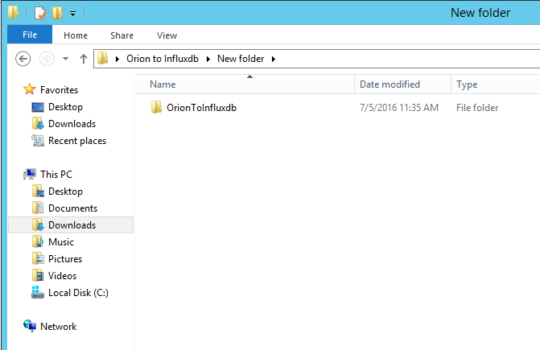

Step 2: Locate OrionToInfluxdb.exe file. Double click to RUN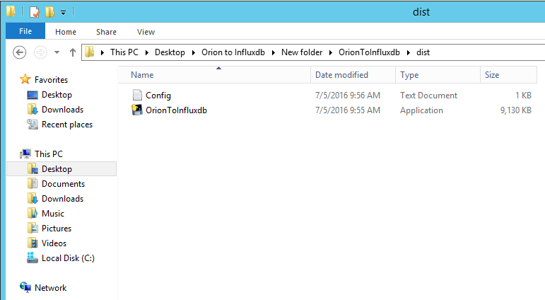

Step 3: The GUI will pop up along with Command Prompt (2 Panels).

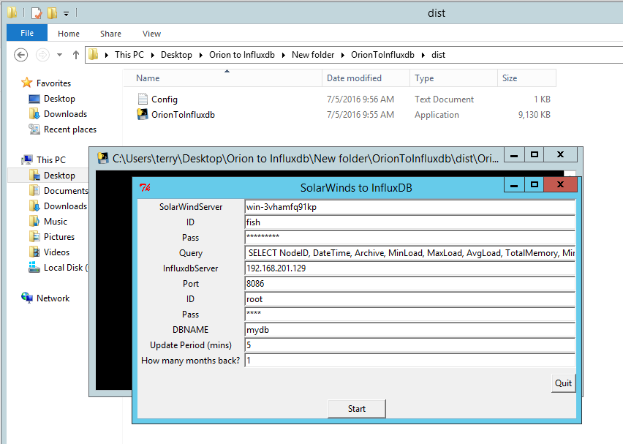

* **SolarWindServer:** This is the IP address or Machine Name, on which your ***SolarWinds*** is running. Eg: **192.168.1.1 or localhost or *machineName\***
* **ID:** Authorization ID for Solarwinds Server. Eg: **admin**
* **Pass:** Authorization Password for Solarwinds Server. Eg: **admin**
* **Query:** Query String for data that you want to pipe from SolarWinds to InfluxDB, remember to include **\*DateTime\*** as the software is expecting time series database. Eg: **SELECT** NodeID, DateTime, MinLoad **FROM** Orion.CPULoad

**\*Note: Do not input Data Manipulation Keywords like *Order by*, etc. Since it is not necessary to order or group the data.**

* **InfluxdbServer: :** This is the IP address or Machine Name, on which your ***InfluxDB*** is running. Eg: **192.168.1.1 or localhost or *machineName\***
* **Port:** The port number that your **InfluxDB** server. Eg: (Default) 8086
* **ID:** Authorization ID for Solarwinds Server. Eg: **root**
* **Pass:** Authorization Password for Solarwinds Server. Eg: **root**
* **DBNAME:** Give your new database a Name. Eg: **mydb**
* **Update Period (mins):** How frequent do you want to update your InfluxDB database. Eg: 1 (every 1 minute)
* **How many months back:** This is useful for the very first time loading the Database from ***SolarWinds*** to ***InfluxDb***¸which indicate how long ago the data should be loaded. Eg: 1 (1 month)

Step4: **Start** importing data to Influxdb. **Command Prompt** will indicate the process has started.

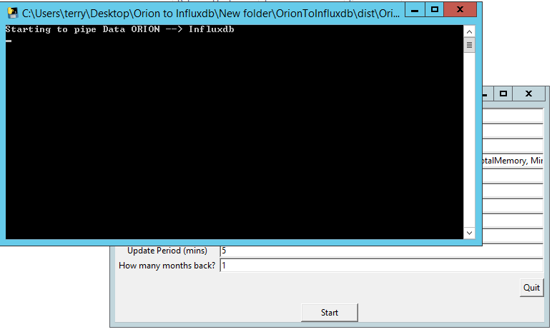

Step 5: Keep **BOTH** windows running in background to ensure the data is updated every *Period* minutes interval. And carry on with your work.

**Extra:** You can set default Server IP, Server ID, Server Password and the rest of the fields by editing the **Config.txt** file (place the file inside the same folder as your **OrionToInfluxdb.exe**).

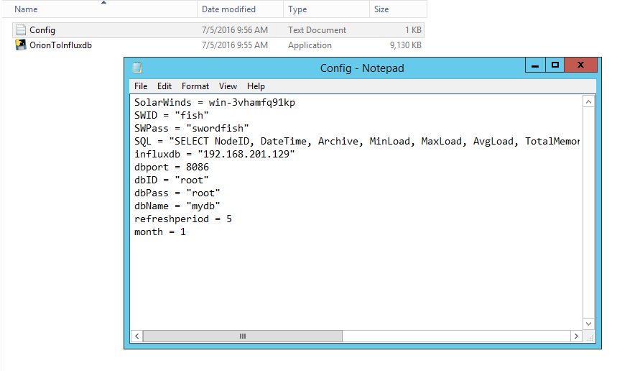

# 3. Source Code

The program is building using Python 2.7. The source code is included* in the package with the name **OrionToInfluxdb.py .** Detail code explanation can found inside the code (written as comment)

Code Summary:

1. Establish connection to SolarWinds Server
2. Establish connection to InfluxDB Server
3. Checking Query String for parsing purposes
4. Request data (using Query String) from SolarWinds Sever
5. Process the returned result from SolarWinds
6. Post processed data to InfluxDB
7. Repeat every *minutes interval

# 4. Author

Name: Nguyen Luong Chuong Thien

Last updated: July 5, 2016

Email: [terryn@ncs.com.sg](mailto:terryn@ncs.com.sg) or [nl.chuongthien@u.nus.edu](mailto:nl.chuongthien@u.nus.edu)